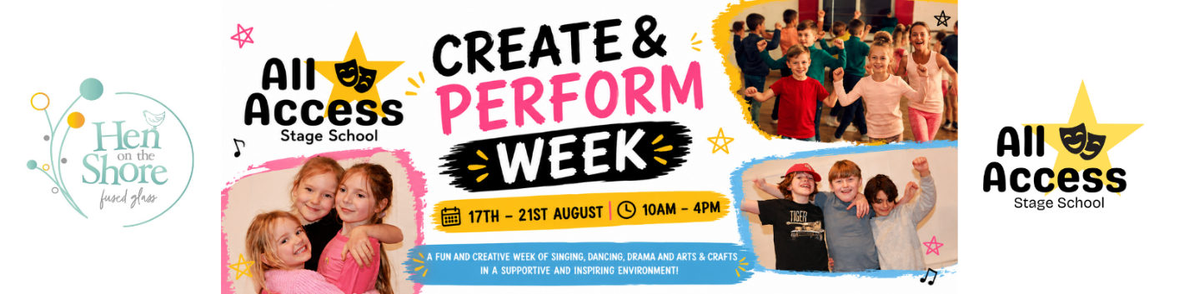

CREATE & PERFORM WEEK
Holiday Activity Week Addendum & Parent Information
All Access Performing Arts & Fitness

Dates: 17th–21st August 2026
Venue: St John's C of E School, Lacey Green, HP27 0PL
Times: 10:00am – 4:00pm daily
This Addendum forms part of the All Access Performing Arts & Fitness Children's Terms & Conditions and should be read alongside all existing policies available upon request.

1. About Create & Perform Week
Create & Perform Week is a holiday activity programme combining performing arts, creative workshops, arts and crafts, team-building activities and an end-of-week performance.
Activities may include:
• Drama
• Musical Theatre
• Singing
• Dance
• Arts & Crafts
• Creative Projects
• Team Games
• Confidence Building Activities
• Group Performances
Activities may vary throughout the week at the discretion of All Access Performing Arts & Fitness.
To ensure all children have the best possible experience, participants may be grouped according to age, ability, experience level or activity requirements. Some activities may be delivered in separate age groups where appropriate.

2. Registration Requirements
All participants must have a completed registration form before attending.
Parents/carers must provide accurate and up-to-date information regarding:
• Emergency contacts
• Medical conditions
• Allergies
• Medication requirements
• Additional needs
• Collection arrangements
It is the responsibility of parents/carers to notify us of any changes to this information.

3. Arrival & Collection
Children may be dropped off from 9:50am.
Activities begin promptly at 10:00am.
Children must be collected no later than 4:00pm unless an extended-hours arrangement has been agreed in advance.
For safeguarding reasons:
• Children under 16 must be signed in and out by an authorised adult.
• Any changes to collection arrangements must be provided in writing.
• Identification may be requested if collection arrangements differ from those stated on the registration form.

4. Late Collection
Parents/carers are expected to collect children promptly at the end of each day.
Where a delay is unavoidable, parents/carers should contact All Access as soon as possible.
Persistent late collection may result in an additional charge.

5. Food & Drinks
Parents/carers must provide:
• A packed lunch
• At least one drink bottle
• Any additional snacks required
Please do not send products containing nuts due to the potential presence of severe allergies.
Children should bring sufficient food and drink for the duration of the day.

6. Clothing & Personal Belongings
Children should wear comfortable clothing suitable for movement, creative activities and the weather conditions.
Suitable footwear must be worn at all times.
As arts and crafts activities may involve paint, glue and other materials, children should not attend in clothing that is valuable or requires special care.
All personal belongings should be clearly labelled.
All Access accepts no responsibility for lost, damaged or stolen property.

7. Arts & Crafts Activities
Children may participate in supervised arts, crafts and creative projects during the week.
Activities may involve:
• Paint
• Glue
• Pens and pencils
• Craft materials
• Child-safe scissors
• Recycled materials
• Decorative materials
All activities will be age-appropriate, risk assessed and supervised by staff.
Parents must notify us of any allergies, sensitivities or medical conditions that may affect participation.
Whilst reasonable precautions will be taken, All Access cannot guarantee that clothing will remain free from marks or stains.

8. Medical Needs & Medication
Parents/carers must disclose all relevant medical information before attendance.
Medication required during the day must:
• Be clearly labelled
• Be handed directly to a member of staff
• Include written instructions where appropriate
Emergency medication (including inhalers and EpiPens) must be available throughout the week where required.

9. Behaviour Expectations
Children are expected to:
• Treat others with kindness and respect
• Follow instructions from staff
• Participate safely
• Respect school property and equipment
• Support and encourage fellow participants
Bullying, discriminatory behaviour, violence, intimidation or deliberate damage to property will not be tolerated.
Serious or repeated behaviour concerns may result in a child being collected early or removed from the remainder of the programme without refund.

10. Photography & Video
Photography and video may be taken throughout the week for promotional, educational and celebratory purposes in accordance with the All Access Media, Imagery & Social Media Policy.
No child will be photographed or filmed without the appropriate consent being provided on the registration form.

11. Mobile Phones & Electronic Devices
Children may bring mobile phones or personal electronic devices to Create & Perform Week at their own risk.
Where brought to the venue:
• Devices should remain switched off or on silent mode during activities.
• Devices should be stored safely in bags when not in use.
• Use of devices during activities is not permitted unless authorised by a member of staff for a specific purpose.
• Participants must not take photographs, videos or audio recordings of other children, staff or activities without permission from a member of staff.
All Access Performing Arts & Fitness accepts no responsibility for the loss, theft or damage of personal electronic devices brought to the venue.
Any use of devices that compromises safeguarding, privacy, wellbeing or the enjoyment of others may result in the device being confiscated for the remainder of the session and returned to a parent/carer at collection time.

12. End-of-Week Performance
An informal performance for family and friends will take place on Friday 21st August 2026.
Performance times and details will be communicated separately.
Participation is encouraged but not compulsory.
Parents/carers acknowledge that performance activities may be photographed or filmed in accordance with existing consent permissions.

13. Cancellation & Refund Policy
If a parent/carer cancels:
• More than 28 days before the start date – a full refund will be issued minus any non-refundable booking fee.
• Between 14 and 28 days before the start date – a 50% refund will be issued.
• Less than 14 days before the start date – no refund will be issued unless the place can be filled from a waiting list.
If Create & Perform Week is cancelled by All Access Performing Arts & Fitness, a full refund or suitable alternative arrangement will be offered.

14. Illness & Absence
No refunds or credits will be given for days missed due to:
• Illness
• Holidays
• Appointments
• Family commitments
• Any other absence outside the control of All Access
Parents/carers must not send children who are suffering from contagious illnesses or who are otherwise unfit to participate safely in activities.

15. Emergency Procedures
In the event of an accident, illness or emergency:
• First aid will be administered where appropriate.
• Parents/carers will be contacted as soon as reasonably possible.
• Emergency services may be contacted if necessary.
• Relevant information may be shared with medical professionals where required to protect the welfare of the child.

16. Acceptance
By registering for Create & Perform Week, parents/carers confirm that they have:
• Read and understood this Addendum.
• Read and accepted the All Access Children's Terms & Conditions.
• Read and accepted all associated policies.
• Provided accurate information relating to their child.
All Access Performing Arts & Fitness reserves the right to amend this document where reasonably necessary. Any significant changes will be communicated to families.
All Access Performing Arts & Fitness
www.allaccess-bucks.com
zoe@allaccess-bucks.com
07516 734 686

